Josiah Silverberg
Professor Sanchez
Special Topics in Cybersecurity
December 1, 2025

CTF Writeups
NCL-Individual games
Password Cracking
- For password cracking, hashes were given for a handful of passwords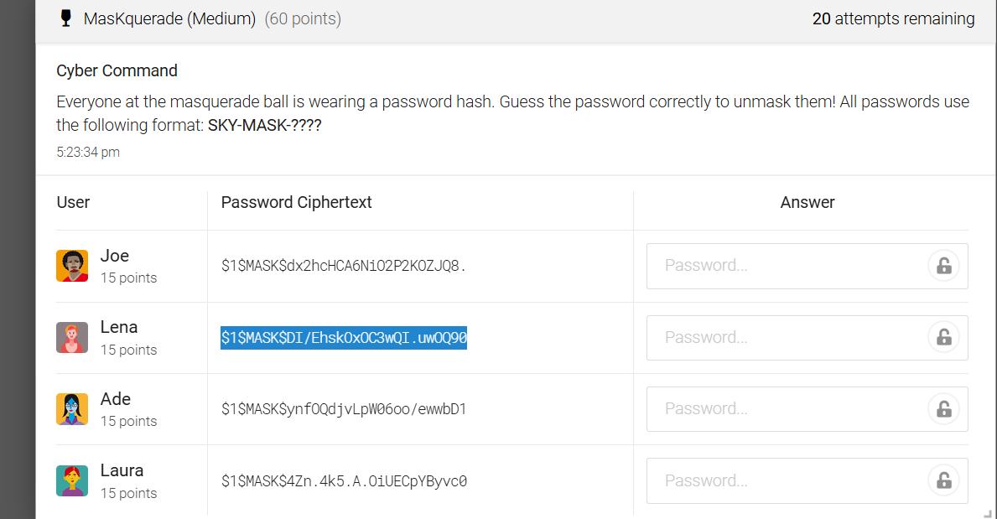
Using hashcat, I was able to construct the full passwords for each
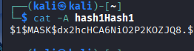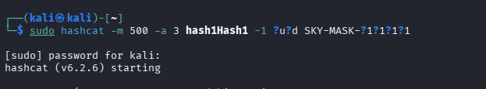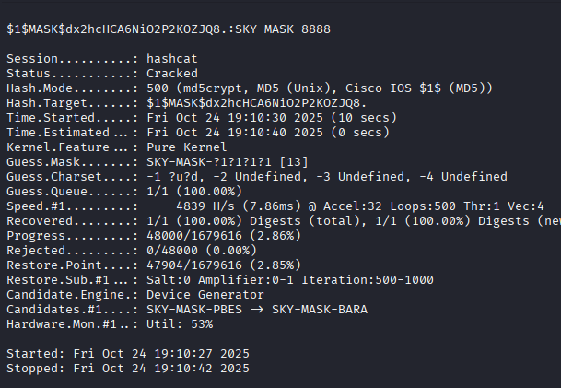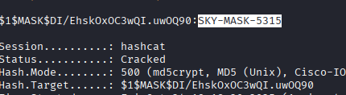
Next set, I stripped the first half of the hash (Before the colon) then used the NTLM hashcat setting to crack each of the passwords 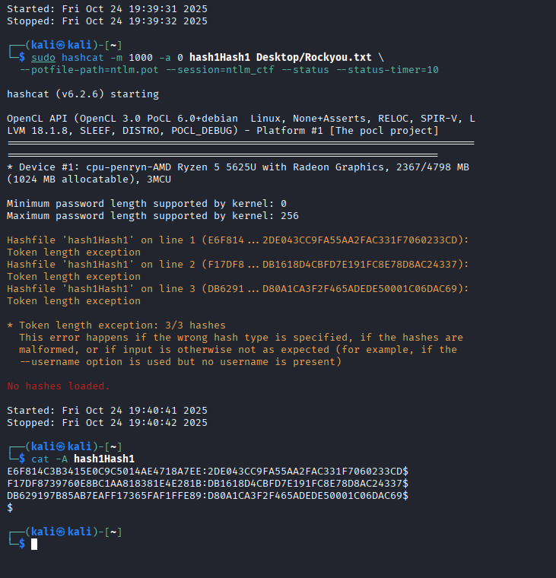
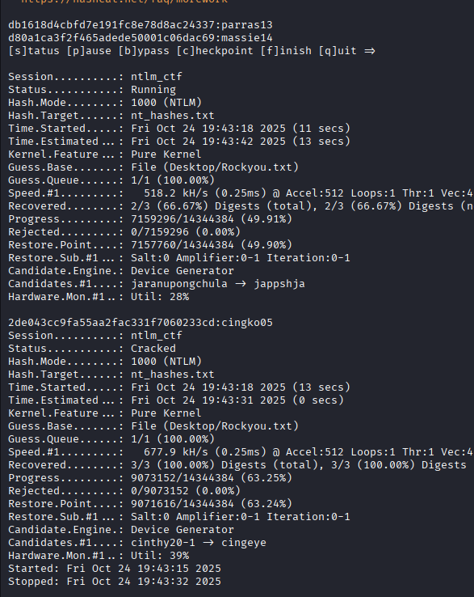
- Network Traffic
The first task was to identify the IP address of the DNS server. Looking at the DNS records, you can see a client querying another IP address for a DNS response, meaning this is the DNS server. (192.168.100.2)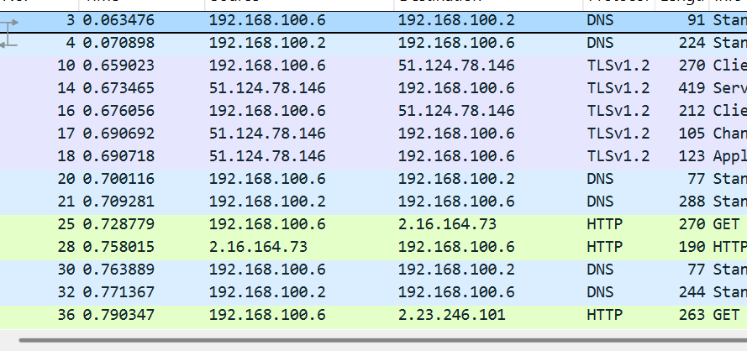
Afterwards, we must find the FQDN from which the malicious tool was installed. We can find an odd FQDN named agentinstall.fleekdesk.io, which is the answer.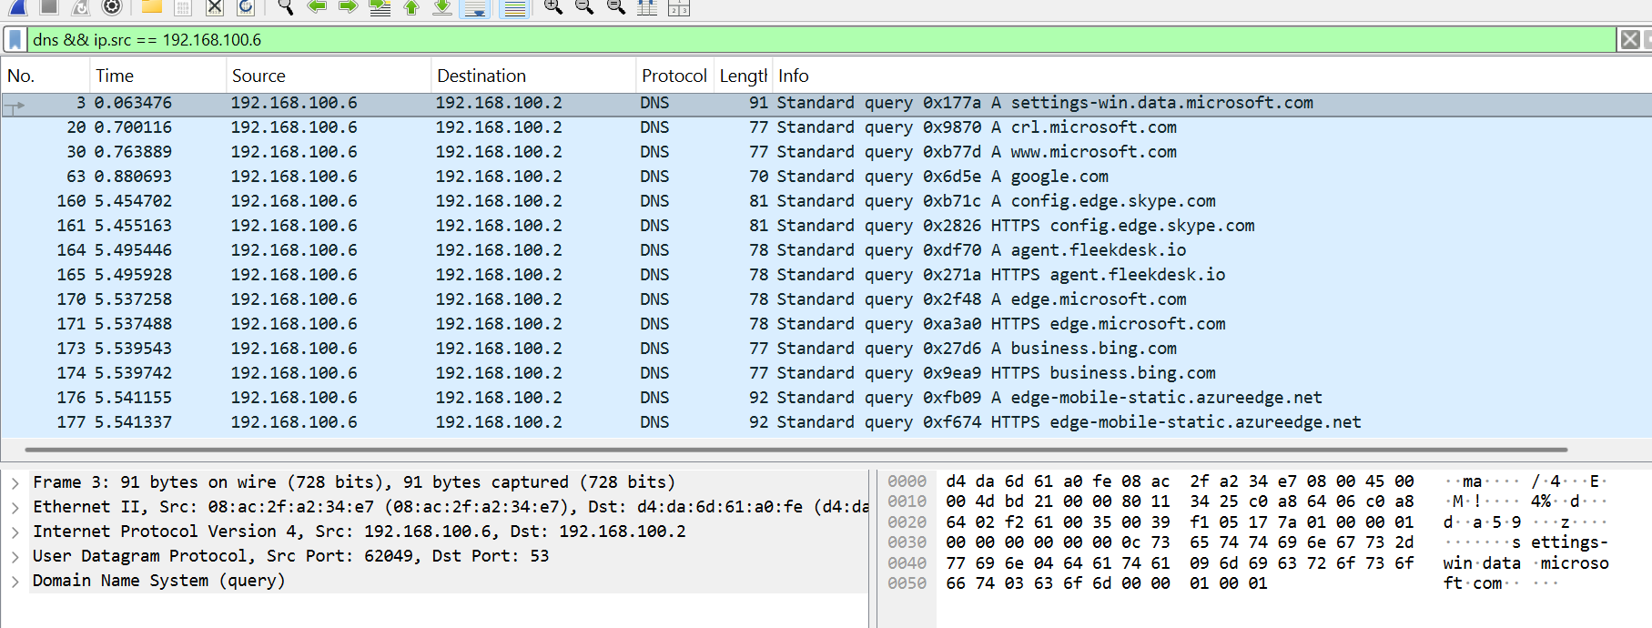
Its IP address is asked for next, being 3.160.150.50 as given in the image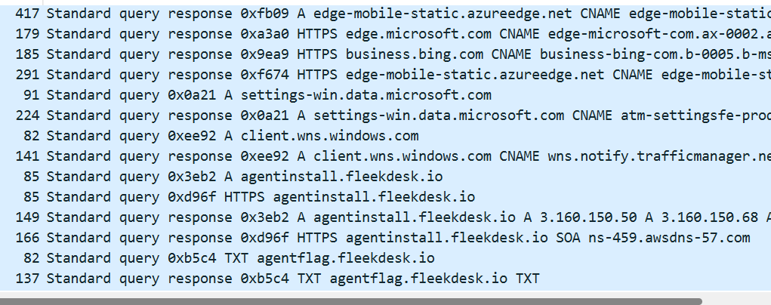
The same line also gives its record: HTTPS.

- Log Analysis
First question was to find bootstrap exe downloaded by the web browser. To find this, we must look to where a web browser (Chrome in this case) was used, and what it installed 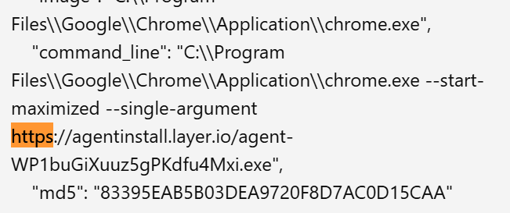
We can see that a process known as agentinsall.layer.io…exe is found, indentifying the excecutable.
Next question asks what the name of the main agent executable launched after the bootstrap runs. We can see that the process layer_agent_svc.exe only runs AFTER the bootstrap, meaning it is the answer here. 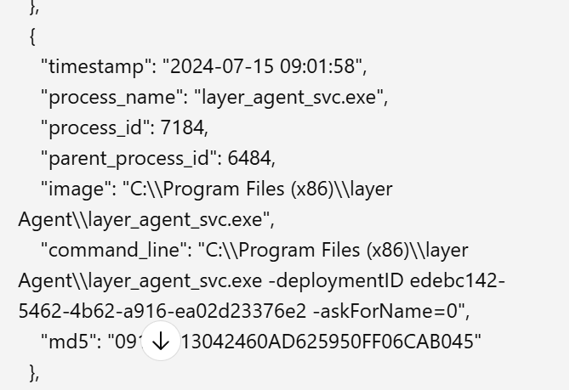
Next question asks Which PowerShell cmdlet is used to create the firewall rules for the agent’s traffic. We can do a word search and find PowerShell here 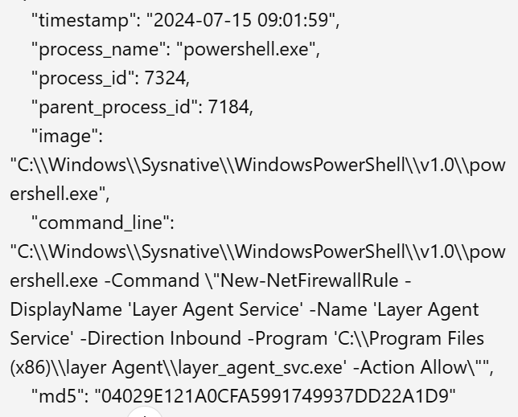running “New-NetFirewallRule”, which is the answer
Next question asks which program is executed to verify that the main agent is running. We can see task manager running later, which would be used for this task. 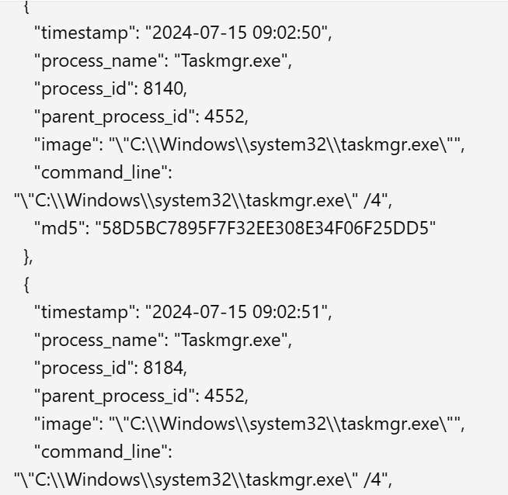
Next one asks what is the process ID of the executable used to re-enable Windows Defender. We can word search windows Defender and get this process ID, 1704. 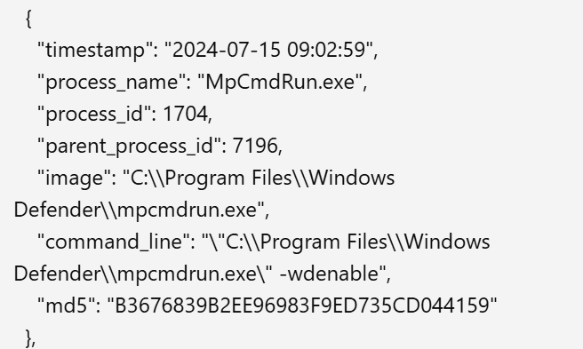
Lastly, we are asked how many seconds after the last firewall rule was created, was Defender re-enabled. Going back to the firewalls creation (9:02:13) and it being re-enabled (9:02:59) we can conclude that 46 seconds passed. 